The 2012 Outstanding Women Law Students of the Women Lawyers Association of Michigan Foundation

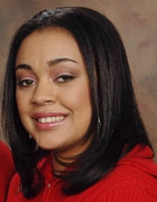
Donnica Blackful, WLAMF/Dickinson Wright Women’s Network Scholar at Thomas M. Cooley Law School

While attending Chicago State University, Donnica interned at Between Friends as a Legal Advocate and Crisis Hotline Worker for victims of domestic violence. After graduating, she moved to Lansing to attend Cooley Law School. While at Cooley, Donnica interned with E.V.E. Inc.'s Personal Protection Office where she, again, was able to assist victims of domestic violence by helping them get protection orders and by providing them with crisis intervention and resources. She also helped raise money and personal products for women at E.V.E. Inc.'s shelter for Domestic Violence Awareness Month in October of 2010. On a personal note, Donnica mentors other moms who are struggling with the difficulties of raising a child while in law school.


Claudia C. Boonenberg, WLAMF/General Motors Scholar at University of Detroit Mercy School of Law

Claudia graduated from the University of Michigan in 2007 and received a Master’s degree from the Manhattan School of Music in 2009. Claudia is now a 3L at UDM, and is an extremely active member of the community there. She is a student member of the school’s Career Services Advisory Board, Symposium Editor of the Law Review, and a member of the McGee National Civil Rights Moot Court Team. By far Claudia’s favorite and most cherished activity at school is being President of the Women’s Law Caucus. Under her leadership, the group is establishing a mentorship program for female UDM Law students and alumni, and participating in many fundraising and service activities for area groups such as Alternatives for Girls. After graduation, Claudia hopes to practice business or family law.


Theresa D’Andrea, WLAMF/General Motors Scholar at University of Michigan Law School

After graduating from Cornell University, Theresa spent a year working at a firm, where she became involved in various pro bono projects, including helping young children receive Special Immigration Juvenile Status to stay in the United States. At UM Law School, Theresa has interned with Lawyers For Children and the Legal Aid Society, and worked as a student attorney with the Pediatric Advocacy Initiative, where many of her clients are single mothers from Washtenaw, Oakland, and Wayne counties. She helps these single mothers to receive public benefits or child support, more parenting time, or proper educational placement for their children. She has also served as President of Legal Advocates for Children and Youth, as well as a research assistant for the National Quality Improvement Center on the Representation of Children in the Child Welfare System. Theresa hopes practice as a family lawyer upon graduation.


Jaclyn Kelley, Kimberly M. Cahill Scholar at the University of Michigan Law School
Jaclyn has advocated on behalf of women and girls in both the education and legal realms. After graduating from Ithaca College in 2008, she taught English in Spain for a year, later using her language skills to teach a bilingual program for elementary school girls as an AmeriCorps volunteer with Girls Inc. The program focused on empowering all girls to be “strong, smart, and bold” through literacy and activism. Thus inspired to continue working with women’s issues, Jaclyn has volunteered at the Michigan Immigrant’s Rights Center, representing female immigrant victims of domestic violence. She worked during her first law school summer at a legal aid clinic in California, where she assisted persecuted women immigrants apply for asylum. Currently, she represents victims of sex trafficking at the Human Trafficking Clinic, and is also the President of the Michigan Immigration and Labor Law Association. She intends to continue her passionate advocacy on behalf of women throughout her legal career.

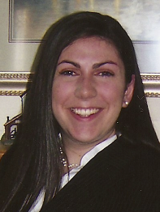
Heather Piotrowski, WLAMF/General Motors Scholar at Wayne State University Law School
During law school, Heather interned for Chief Justice Young at the Michigan Supreme Court and Chief Judge Rosen at the Federal District Court for the Eastern District of Michigan. After her second year, Heather worked in the Domestic Violence division of the Wayne County Prosecutor's Office where she was able to make a difference in the lives of many women by helping them overcome tragic experiences. Heather also works as a Student Attorney at the Small Business and Nonprofit Enterprises Clinic and serves as the Production Editor of the Wayne Law Review. After graduation, Heather would like to remain in Michigan and continue serving the Metro Detroit population.


Lindsay Pohlman, WLAMF Scholar at Michigan State University College of Law
Lindsay graduated from St. Bonaventure University in 2010 with a bachelor’s degree in Journalism and Mass Communications and a Masters in Business Administration. During her time at St. Bonaventure, she started a non-profit organization called Embrace it Africa, which is focused on bringing economic viability to a small village in Southern Uganda. Among its many projects, Embrace it Africa manages an orphanage of over 650 children and runs a HIV/AIDS widows group focused on economic community development. After Lindsay’s first year at Michigan State University College of Law, she interned at the Legal Aid Bureau of Buffalo in the Civil Services Department, where she focused on domestic violence cases and civil issues in conjunction with Buffalo’s pilot federal reentry program. At MSU, Lindsay is the Vice President of the Public Interest Law Society and she works with the Jessup International Moot Court Team.


Linda Rawls, WLAMF Scholar at Thomas M. Cooley Law School
After separating from the United States Air Force and the Delaware Air National Guard, Linda obtained her BS in Behavioral Science from Wilmington University, volunteered at a women’s prison, and became a counselor at the Baylor Correctional Institute for Women, where she focused on behavioral modification for women who experienced alcohol or substance abuse. Later, Linda volunteered in Russia at the MiraMed Institute and Angel Coalition to help prevent trafficking in women and children, providing assistance with grant writing. She then worked at East Texas Crisis Center as the Program Coordinator to assist women and their children find stable housing once they transitioned out of the shelter, after leaving an abusive relationship. She serves as a Class Representative at Cooley and sits on the executive board of several student organizations. Linda’s team won the First Year Mock Trial Competition and after graduating in January 2014, she plans to complete a judicial clerkship with the goal of focusing on litigation.

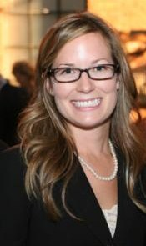
Grace Trueman, WLAMF Scholar at University of Detroit Mercy School of Law

Grace Trueman graduated third in her class from Michigan State University in 2008, with a degree in political science and a specialization in women, gender, and social justice. Since beginning at the University of Detroit Mercy School of Law in 2009, Grace has become a WLAM student member, published author, Law Review title editor, Women’s Law Caucus member, Dean’s Honor Society member, and research assistant. In March of this year, Grace will begin interning for Justice Hathaway of the Michigan Supreme Court, and eagerly anticipates beginning her legal career at Dickinson Wright PLLC in the Fall of 2012. Grace volunteers with a therapeutic riding center in Clarkston, Michigan called Offering Alternative Therapy with Smiles (O.A.T.S), where she has been able to help both girls and boys with their cognitive and physical skills while on horseback. Committed to the helping those with disabilities, Grace will actively seek pro bono work serving those in need, upon admittance to the bar.

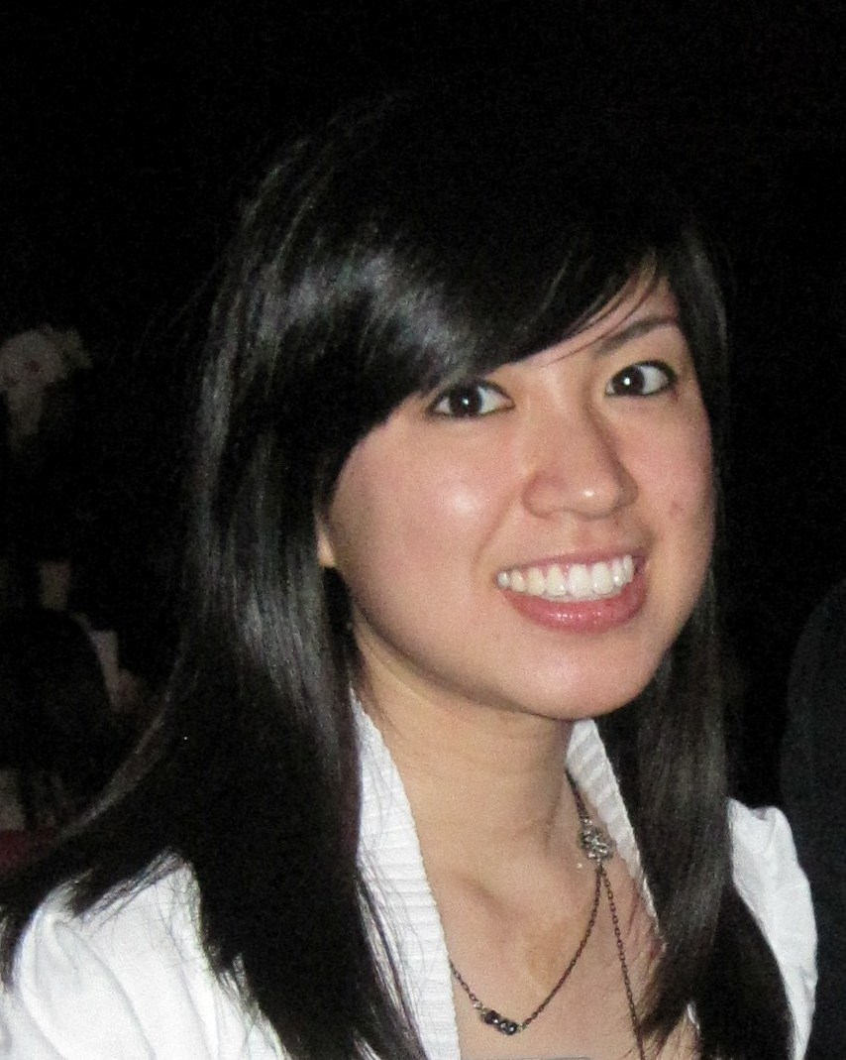
Eleanor Ung, WLAMF Scholar at Wayne State University Law School
Eleanor Ung started college at 16 and became the first president of a leadership organization called Ideal Leaders Association at UCLA. She served as an Emergency Advocate at the Center for Pacific Asian Family, where she counseled domestically abused and sexually harassed victims at a domestic violence shelter. At Wayne Law School, Eleanor has served as President of the Asian Pacific American Law Student Association, Governor-at-Large of the Student Bar Association Board of Governors, and Note Editor of the Journal of Law in Society. She has worked for the law school’s Disability Law Clinic and Small Business & Nonprofit Corporations Clinic. She was a judicial extern for the Honorable Fred Fujioka in the Los Angeles Superior Court, and she was a law clerk for the San Bernardino County Public Defender Office. In November 2011, the National Asian Pacific American Student Association selected Eleanor for its “Student of the Year” award.

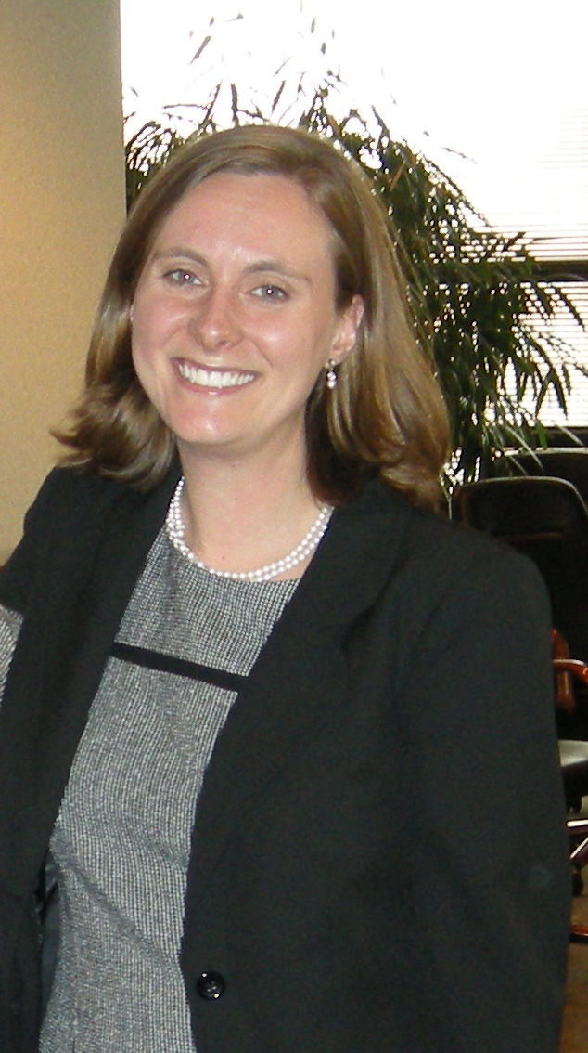
Sarah Warpinski, WLAMF/General Motors Scholar at Michigan State University College of Law
Sarah is a second year student at Michigan State University College of Law, where she focuses on immigration and criminal law. After completing her first year of law school, Sarah volunteered as a summer legal intern in La Paz, Bolivia with International Justice Mission, as an advocate for child victims of sexual assault. Sarah decided to attend law school in order to protect child victims of sexual exploitation, especially human trafficking. Sarah is dedicated to community collaboration to serve victims, and is an active member of the Michigan Human Trafficking Task Force and the founder and chairperson of the Modern Abolitionist Legal Society. Sarah recently returned from living in Mozambique, Africa, where she worked with Samaritan’s Purse International Relief. She has also lived and worked in Liberia, Brazil, and Honduras. Prior to living overseas, Sarah worked as a bilingual home visitor, family assessment worker, and youth advocate in Wisconsin and Michigan. Sarah graduated from Calvin College in 2005 with a Bachelor’s degree in International Development and Spanish.

